Kingston NV3 PCIe 4.0 NVMe SSD

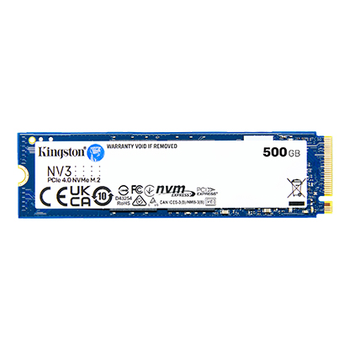

**Key Features:**

* **High-Speed Performance:** Utilizing a Gen 4x4 NVMe controller, the NV3 offers sequential read speeds up to 6,000MB/s and write speeds up to 5,000MB/s, ensuring rapid data access and transfer.

**Applications:**

* Ideal for upgrading older PCs or laptops for better speed and performance.
* Perfect for storing operating systems, games, and frequently accessed files.
* Budget-conscious solution for everyday computing tasks, including web browsing, streaming, and productivity work.

**Ideal For:**

* Users seeking high-speed storage solutions for everyday computing tasks.
* Gamers and content creators requiring quick data access and transfer.
* Systems with limited space, such as thin laptops and small form factor PCs.

**Energy-Efficient Performance:**

* Operates with optimized power consumption and low heat generation, ensuring consistent performance even during intensive tasks.

**Warranty and Support:**

* Kingston offers a limited 3-year warranty for the NV3 SSD, along with free technical support, ensuring reliability and assistance when needed.